|  |
| --- |
| Photo displaying partial image of two pie charts on a canvas-textured page |
| **Power BI Capstone project**  **Bank Loan Performance Analysis** |
| |  |  |  | | --- | --- | --- | | P. Zahir Hussain | 8/22/24 | TN DSML May 2024 | AN-B4 | |

**Project Manager**

Entri Elevate

**Coding Mentor**

Janani Lakshmi

Narayanan

**Instructors**

Archana S

**Coordinator**

Rafsal A

# CHAPTER - I

**INTRODUCTION:**

The transfer of funds from one party to another with the commitment to repay it is known as a loan in the finance industry. In exchange for using the money, the borrower, also known as the recipient, incurs debt and typically has to pay interest.   
  
Typically, the promissory note or equivalent paperwork proving the debt will include the principle amount borrowed, the interest rate the lender is charging, and the repayment date. A loan means that the borrower and the lender will temporarily reallocate the subject asset or assets.

The interest gives the lender a reason to proceed with the loan. Each of these duties and limitations in a legal loan is enforceable through contract, which also has the power to impose additional limitations on the borrower known as loan covenants. While the focus of this essay is on financial loans, practically any material object could be lent.  
  
One of the primary functions of financial organizations like banks and credit card firms is to make loans. Bonds and other debt contracts are common sources of finance for other institutions.

**Types:**

**Protected:**

A secured loan is a type of debt where the borrower offers up an asset as security, such as a house or automobile.   
  
Many people utilize a mortgage loan, which is a very popular kind of financing, to buy residential or commercial real estate. Until the mortgage is fully repaid, the lender, which is typically a financial institution, is granted security in the form of a lien on the property title. In the event that a borrower fails on a home loan, the bank is legally entitled to take possession of the property and sell it to recoup any outstanding debt.

In the same way, an auto loan may be backed by the vehicle itself. The loan term is somewhat shorter, frequently matching the vehicle's usable life. Auto loans come in two varieties: direct and indirect. A bank loans money to a customer directly when they get a direct vehicle loan. A car dealership (or a related business) serves as a middleman between the customer and the bank or other financial institution in an indirect auto loan.

Loans secured by securities, such as bonds, mutual funds, shares, etc., are examples of additional secured loan types. Customers can obtain a line of credit through this specific instrument, which is granted based on the quality of pledged securities. Customers who have pledged things are evaluated for the quantity and purity of gold before being granted gold loans. Corporate entities may also obtain secured loans by guaranteeing the company's assets, which may include the business itself. Generally speaking, secured loans have cheaper interest rates than unsecured loans. Before authorizing the loan, the lending institution typically hires individuals (on a contract or roll-call basis) to assess the quality of the pledged collateral.

**Unsecured:**

Financial loans that are not backed by the borrower's assets are known as unsecured loans. Financial institutions may provide them in a variety of forms or marketing bundles:

* Credit histories
* Individual loans
* Overdrafts at banks
* Credit lines or facilities
* Corporate debts, which could be secured or not
* Mutual-to-peer financing

Depending on the lender and the borrower, different interest rates may apply to these various forms. There might be legal regulations on these or not. In the UK, the Consumer Credit Act of 1974 may apply to them where they relate to persons.

Because an unsecured lender has significantly fewer possibilities for taking legal action against the borrower in the case of default, interest rates on unsecured loans are almost always higher than those on secured loans. This is because an unsecured lender is taking on greater risk than they would be with a secured loan. In order to enforce the judgment against the borrower's unencumbered assets—those not previously pledged to secured lenders—an unsecured lender must file a lawsuit against the borrower, win a monetary judgment for breach of contract, and then pursue judgment execution. When a court divides up the borrower's assets during insolvency proceedings, secured lenders typically have precedence over unsecured lenders. Therefore, a higher interest rate represents the added risk that the debt might not be recouped in the event of insolvency.

**Demand:**

Demand loans are short-term loans that typically do not have fixed dates for repayment. Instead, demand loans carry a floating interest rate, which varies according to the prime lending rate or other defined contract terms. Demand loans can be "called" for repayment by the lending institution at any time. Demand loans may be unsecured or secured.

**Subsidized:**

A subsidized loan is a loan on which the interest is reduced by an explicit or hidden subsidy. In the context of college loans in the United States, it refers to a loan on which no interest is accrued while a student remains enrolled in education.

**Concessional:**

A concessional loan, sometimes called a "soft loan", is granted on terms substantially more generous than market loans either through below-market interest rates, by grace periods, or a combination of both. Such loans may be made by foreign governments to developing countries or may be offered to employees of lending institutions as an employee benefit (sometimes called a perk).

**Target markets**

**Personal**:

Finances, auto loans, credit cards, home equity lines of credit, installment loans, and payday loans are examples of common personal loans. An important factor in the underwriting and interest rates (APR) of these loans is the borrower's credit score. If you choose a longer payment term for your personal loan, you can lower the monthly payments, but you will also pay more interest altogether. Banks, alternative (non-bank) lenders, online lenders, and private lenders are all possible sources for a personal loan.

**Commercial:**

Loans to businesses are similar to the above but also include [commercial mortgages](https://en.wikipedia.org/wiki/Commercial_mortgage) and [corporate bonds](https://en.wikipedia.org/wiki/Corporate_bond) and government guaranteed loans Underwriting is not based upon credit score but rather [credit rating](https://en.wikipedia.org/wiki/Credit_rating).

# CHAPTER - II

**AREA OF STUDY:**

**Problem Statement:**

In today's data-driven world, understanding how borrower details and loan characteristics impact loan performance is very important for banking institutions. This project seeks to delve deep into a lending loan dataset to uncover the relationship between borrower behavior (such as employment length, income, and debt-to-income ratio) and loan characteristics (including amount, term, and interest rate) to unearth critical insights into loan performance metrics. By examining patterns in loan statuses such as fully paid, charged off, or late payments, this analysis aims to empower banking institutions with actionable insights to optimize loan lending strategies, mitigate credit risk, and enhance overall portfolio performance.

**Dataset Download:** https://drive.google.com/uc?export=download&id=1yNL9gfv-DlD3cEW9o2GJvtJ9Bzbm37R7

The dataset "bank loan.xlsx" contains two sheets: 1. LoanDetails: This sheet contains information about each loan. 2. BorrowerDetails: This sheet provides details about the borrowers.

**Variable Declaration:**

|  |  |  |
| --- | --- | --- |
| Table Name | Field Name | Description |
| Loan Details | id | Unique identifier for each loan. |
| loan_amnt | The amount of money requested by the borrower. |
| funded_amnt | The actual amount of money funded for the loan. |
| term | The duration of the loan in months. |
| int_rate | The interest rate of the loan. |
| installment | The monthly payment owed by the borrower. |
| grade | The loan grade assigned by the lending company. |
| sub_grade | The loan subgrade assigned by the lending company. |
| issue_d | The month in which the loan was funded. |
| purpose | The reason provided by the borrower for the loan. |

|  |  |  |
| --- | --- | --- |
| Table Name | Field Name | Description |
| Borrower Details | id | Unique identifier for each loan. |
| member_id | Unique identifier for each borrower. |
| emp_length | Employment length in years. |
| home_ownership | The status of home ownership reported by the borrower. |
| annual_inc | The annual income reported by the borrower. |
| verification_status | Indicates if the borrower's income was verified. |
| dti | The debt-to-income ratio of the borrower. |
| delinq_2yrs | The number of past-due incidences in the borrower's credit file. |
| last_pymnt_d | The month of the last payment received. |
| total_pymnt | The total amount received in payments. |
| out_prncp | The remaining outstanding principal amount of the loan. |

**OBJECTIVES:**

1. The Loan Performance Analysis report aims to provide insights into the performance of loans based on various factors such as loan amount, loan status, term, interest rate, and purpose.
2. The Borrower Profile Analysis report aims to provide insights into the characteristics of borrowers such as home ownership, annual income, employment length, verification status, debt-to-income ratio, and delinquency history.

# CHAPTER - III

**METHODOLOGY:**

**1) Importing Data**

Import the "Loan Details" and "Borrower Details" sheets from the "bank loan.xlsx" file into Power BI.

**2) Transformation Using Power Query**

**Data Cleaning:**

Handling Missing Values and Duplicates:

1. Replace missing values (null) in the 'emp_ length' column of the "Borrower Details" table with '0 year'.
2. Remove rows with missing values in the 'last_ pymnt_ d' and 'delinq_2yrs' columns.
3. Remove duplicate rows in the 'id' column of the "Loan Details" table.

Dealing with Inconsistencies:

1. Ensure words in the 'purpose' column are separated by spaces instead of underscores (e.g., "credit card" instead of "credit_card").
2. Format the 'purpose' and 'home_ownership' columns to proper case.

Data Transformation:

Column Transformation:

1. Change the data type of the 'total_pymnt' column to 'Fixed decimal number'.
2. Round off the numbers in the 'funded_amnt' column to 2 decimal places.

Column Renaming:

1. Rename the column 'issue_d' to 'issue_date'.
2. Rename the column 'last_pymnt_d' to 'last_pymnt_date'.

Creating New Columns:

1. Create a new custom column named 'total_amount_paid' to calculate the total amount paid by each borrower by subtracting 'out_prncp' from 'total_pymnt'.
2. Add a new conditional column named 'delinquency_status' to identify if the borrower has any delinquencies. If the number of delinquencies in 'delinq_2yrs' is greater than 0, the status should be "Delinquent", otherwise "Not Delinquent".

Column Dropping:

1. Remove the 'sub_grade' column as that does not significantly contribute to the analysis.
2. Data Modeling:
3. Identify the common column between both the tables and establish relationships between the two tables. Ensure the cross-filter direction is set to "Both". This step is crucial for enabling cross-table analysis and ensuring data integrity within the dataset.
4. Creating Measures and Calculated Columns using DAX
5. Create a new calculated column named 'remaining_installments' using DAX in the "BorrowerDetails" table to calculate the number of remaining installments by dividing the remaining principal amount ('out_prncp') by the monthly installment amount ('installment') and round up the result using the CEILING() function to account for any partial payments.
6. Create a measure named 'Non-Verified Borrowers Count' using DAX to count the number of loans that have been 'Not Verified'.
7. Create a measure named 'Fully Paid Loan Percentage' to calculate the percentage of fully paid loans. Divide the number of loans with a "Fully Paid" loan status by the total number of loans and then format this measure as Percentage.

**Report 1: Loan Performance Analysis**

The Loan Performance Analysis report aims to provide insights into the performance of loans based on various factors such as loan amount, loan status, term, interest rate, and purpose.

1. **Total Funded Amount**: Create a card visual to display the total funded amount.
2. **Fully Paid Loan Percentage**: Create a gauge chart to display the 'Fully Paid Loan Percentage' measure.
3. **Average Interest Rate by Term:** Create a multi-row card to show the average interest rate for each term.
4. **Loan Status Distribution**: Create a pie chart to visualize the sum of total payments by loan status.
5. **Loan Amount by Purpose**: Create a treemap to show the average loan amount by purpose.
6. **Installment Over Time:** Create a line chart to visualize the sum of installments by Year and Quarter of the issue date.
7. **Maximum Total Amount Paid by Loan Status:** Create a column chart to display the maximum total amount paid by loan status.
8. **Minimum Annual Income by Grade:** Create a funnel chart to show the minimum annual income by grade.
9. **Issue Date Slicer:** Add a slicer for the Month of the issue date to enable dynamic data exploration.

**Report 2: Borrower Profile Analysis**

The Borrower Profile Analysis report aims to provide insights into the characteristics of borrowers such as home ownership, annual income, employment length, verification status, debt-to-income ratio, and delinquency history.

1. **KPI Visual:** Create a KPI visual with the sum of total payment as the value, the year of last payment date as the trend axis, and the sum of loan amount as the target. Round off to 2 decimal points and format as $ currency.
2. **Average of Annual Income:** Display the average of annual income using a card visual.
3. **Non-Verified Borrowers Count**: Display the count of non-verified borrowers using a card visual.
4. **Average Debt-to-Income by Delinquency Status**: Create a multi-row card to show the average debt-to-income ratio by delinquency status.
5. **Sum of Loan Amount by Home Ownership**: Create a table to show the total loan amount by home ownership.
6. **Average Remaining Principal by Verification Status**: Create a donut chart to display the average remaining outstanding principal by verification status.
7. **Sum of Delinquencies by Home Ownership**: Create a bar chart to show the total number of delinquencies in the past 2 years by home ownership and filter the visual to display only Mortgage, Rent, and Own.
8. **Max Remaining Installments by Employment Length**: Create a treemap to show the maximum remaining installments by employment length.
9. **Total Amount Paid and Funded Amount Over Time**: Create a line chart to display the sum of total amount paid and the sum of funded amount by the year of last payment date.
10. **Purpose Slicer**: Add a slicer for loan purpose to enable dynamic data exploration.
11. **COLLECTING OF DATA:**

Import the "Loan Details" and "Borrower Details" sheets from the "bank loan.xlsx" file into Power BI.

https://drive.google.com/uc?export=download&id=1yNL9gfv-DlD3cEW9o2GJvtJ9Bzbm37R7

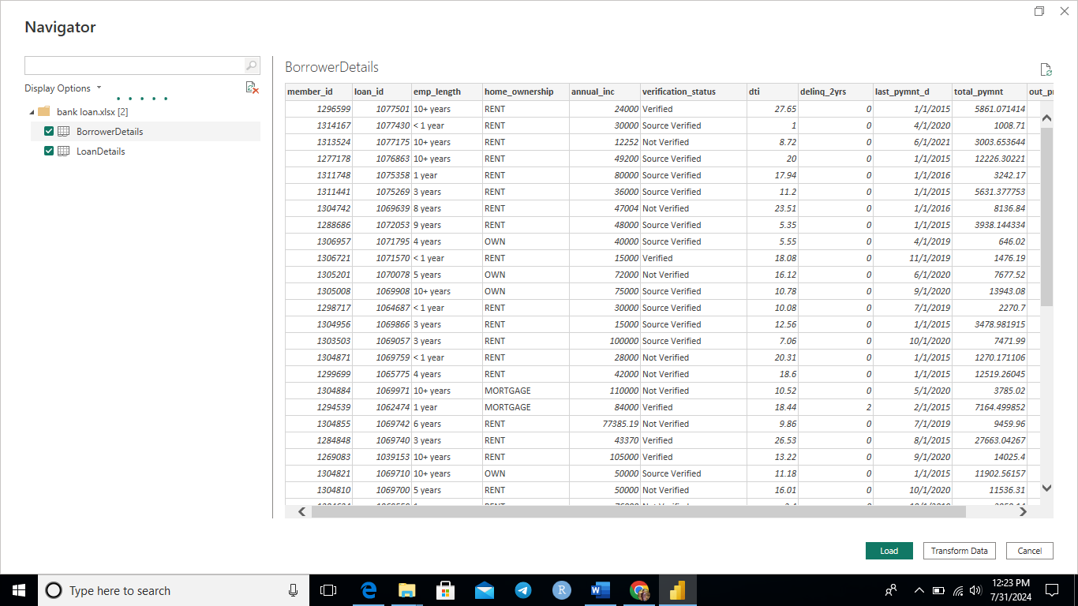

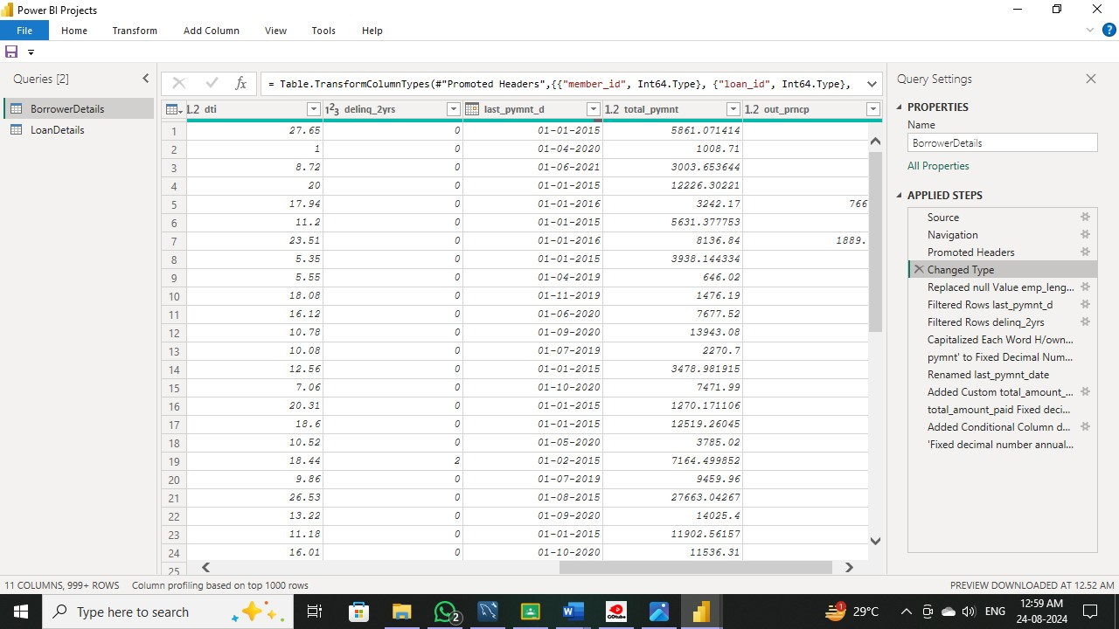

**2) Transformation Using Power Query**

**Data Cleaning:**

Handling Missing Values and Duplicates:

1. Replace missing values (null) in the 'emp_ length' column of the "Borrower Details" table with '0 year'.

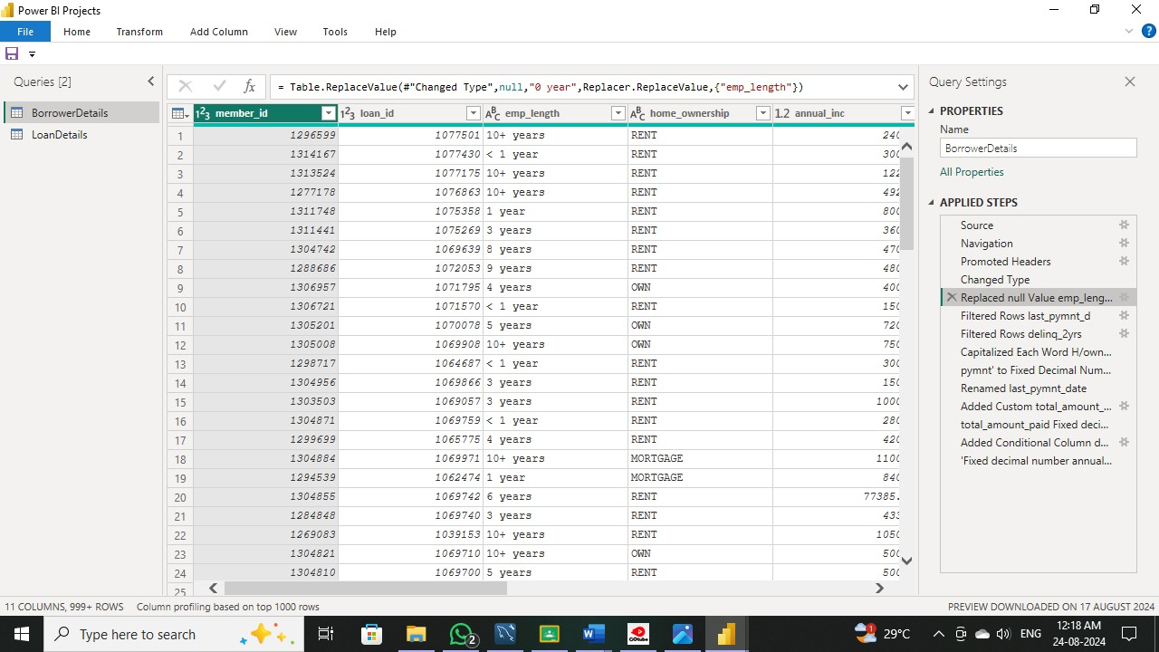

1. Remove rows with missing values in the 'last_ pymnt_d' and 'delinq_2yrs' columns
2. 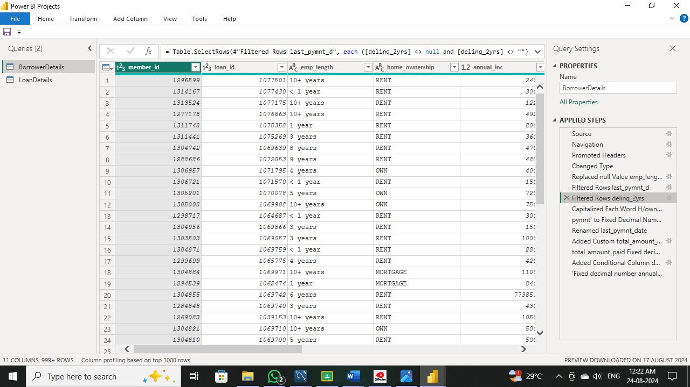

3.Remove duplicate rows in the 'id' column of the "Loan Details" table.

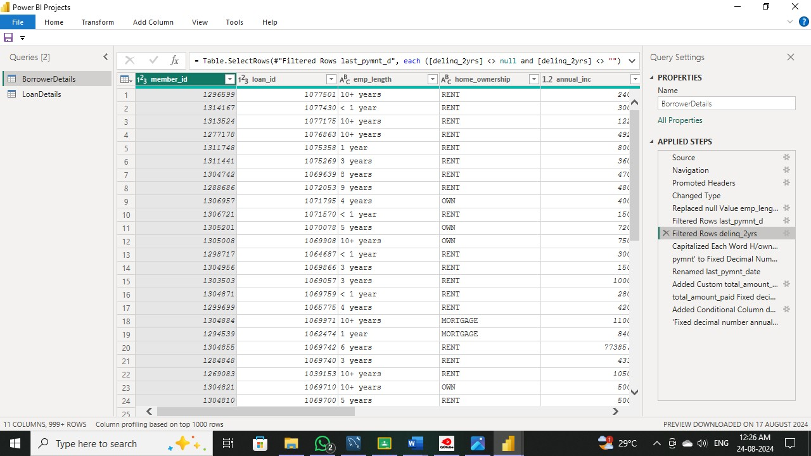

**Dealing with Inconsistencies:**

**1. Ensure words in the 'purpose' column are separated by spaces instead of underscores (e.g., "credit card" instead of "credit_ card").**

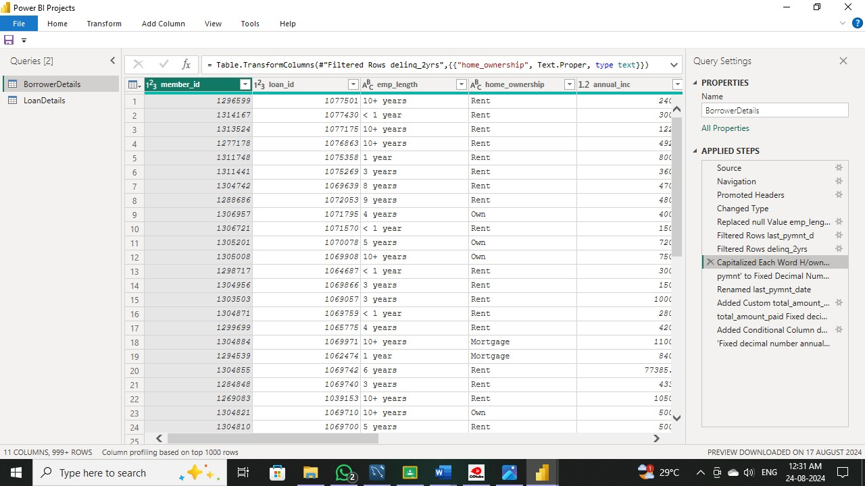

**2. Format the 'purpose' and 'home_ ownership' columns to proper case.**

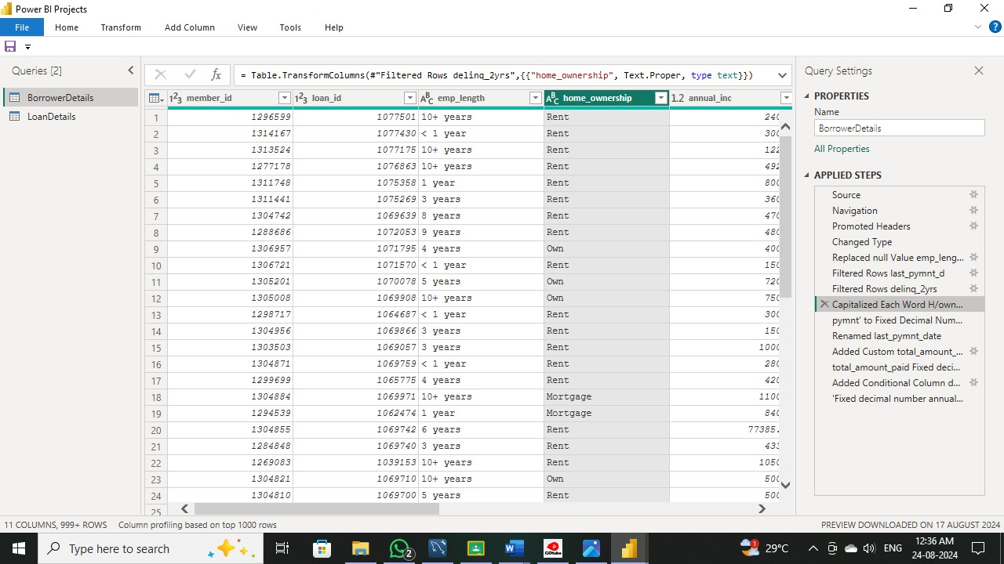

**Data Transformation:**

**Column Transformation:**

1. **Change the data type of the 'total _pymnt' column to 'Fixed decimal number'.**

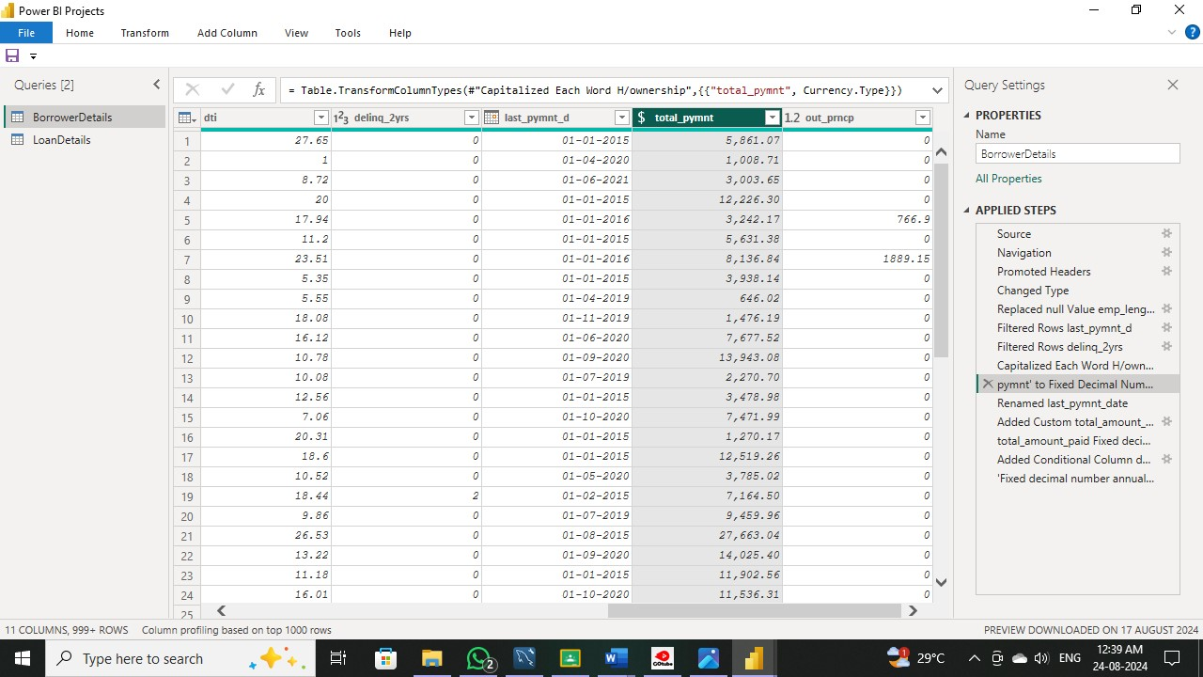

1. **Round off the numbers in the 'funded _amnt' column to 2 decimal places.**

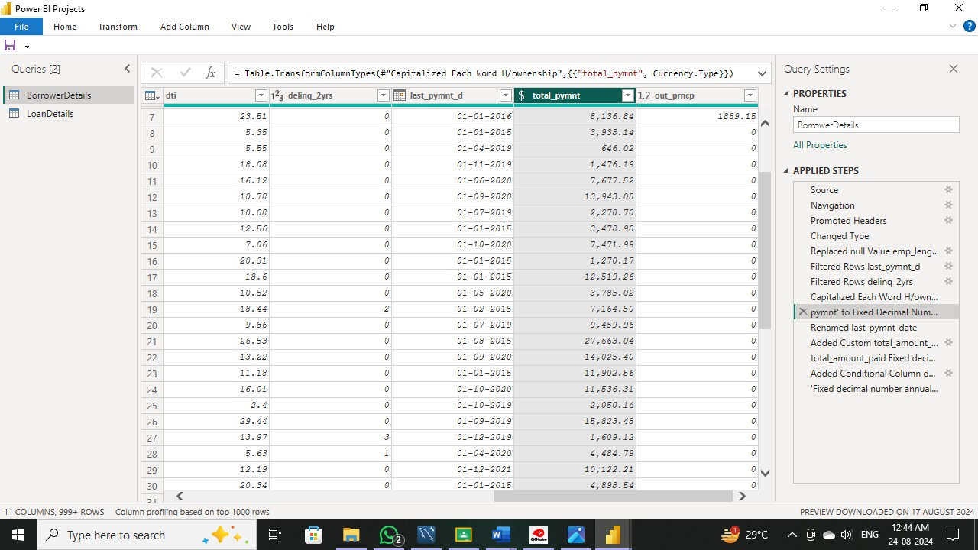

Column Renaming:

1. Rename the column 'issue_d' to 'issue_date'.

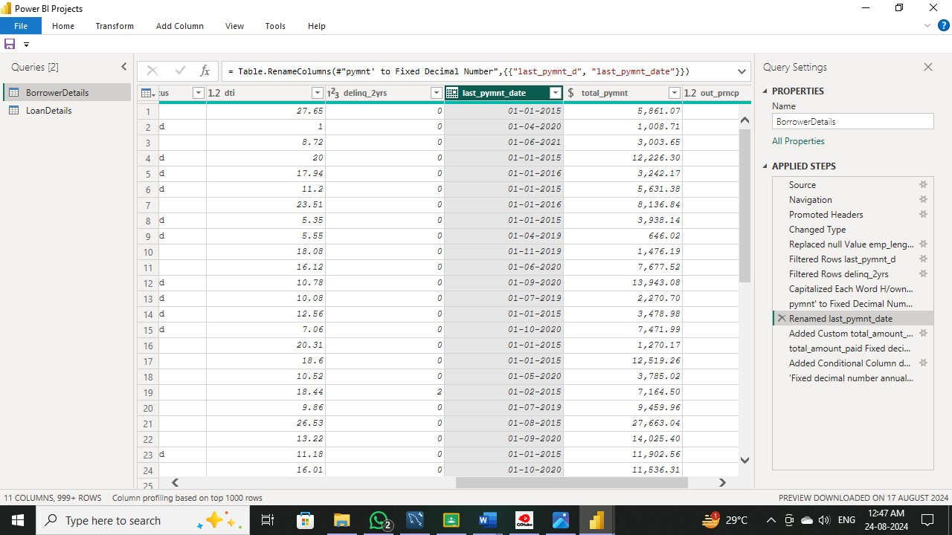

4.Rename the column 'last_pymnt_d' to 'last_pymnt_date'.

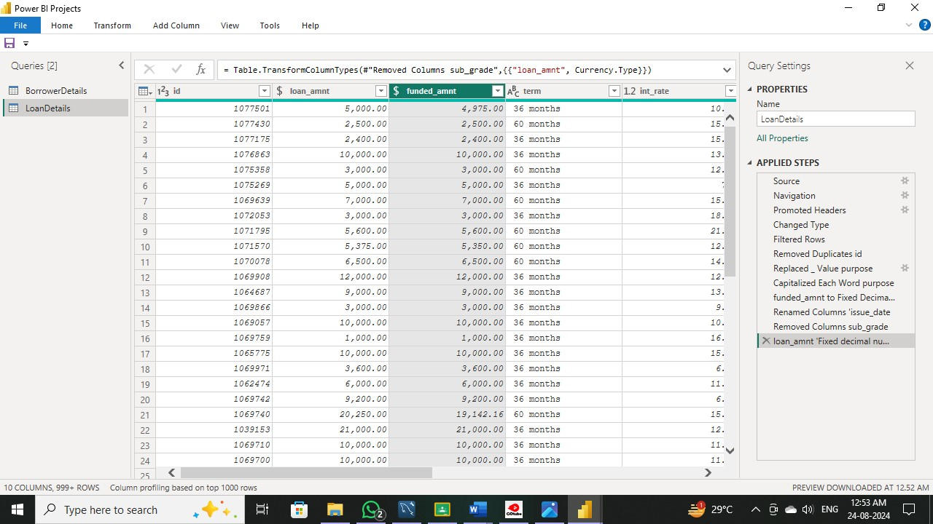

Creating New Columns:

5. Create a new custom column named 'total_amount_paid' to calculate the total amount paid by each borrower by subtracting 'out_prncp' from 'total_pymnt'.



1. Add a new conditional column named 'delinquency_status' to identify if the borrower has any delinquencies. If the number of delinquencies in 'delinq_2yrs' is greater than 0, the status should be "Delinquent", otherwise "Not Delinquent".

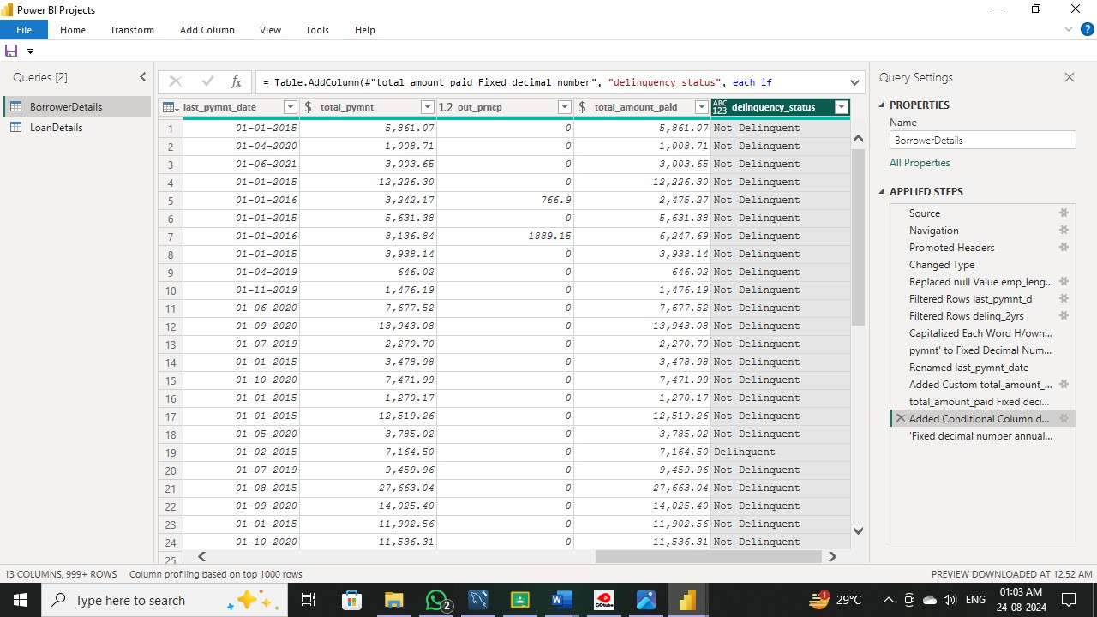

Column Dropping:

1. Remove the 'sub_ grade' column as that does not significantly contribute to the analysis.

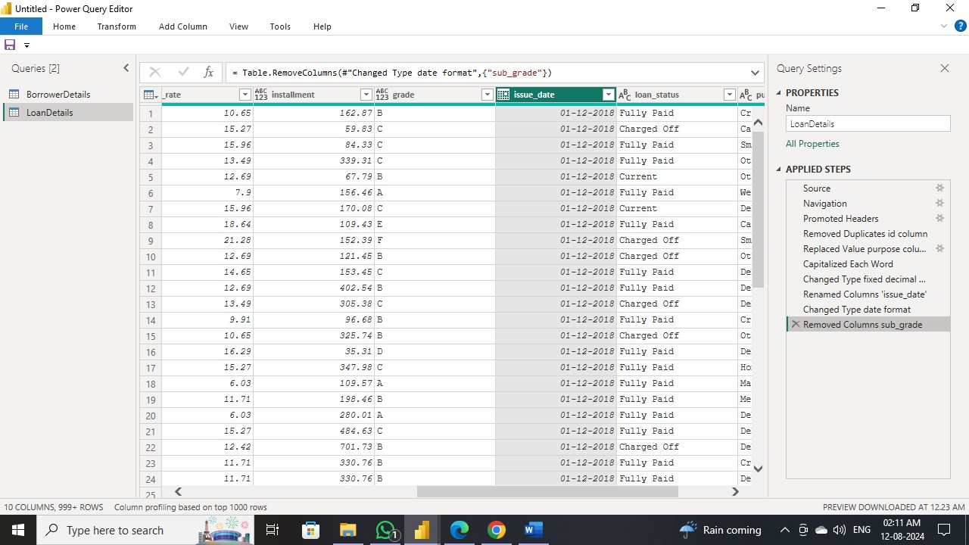

3) Data Modelling:

Identify the common column between both the tables and establish relationships between the two tables. Ensure the cross-filter direction is set to "Both". This step is crucial for enabling cross-table analysis and ensuring data integrity within the dataset.

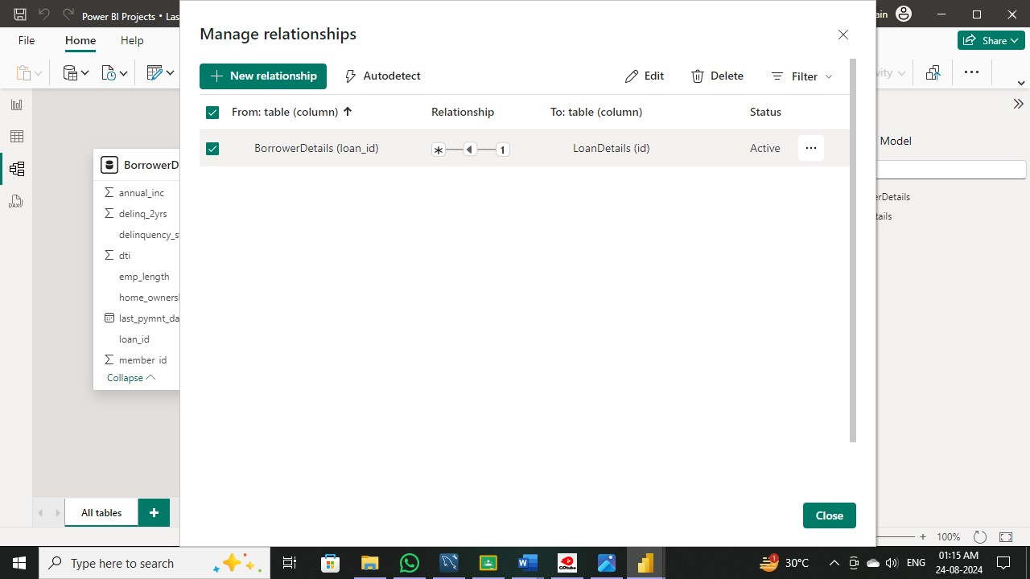

4) Creating Measures and Calculated Columns using DAX:

1. Create a new calculated column named 'remaining _installments' using DAX in the "Borrower Details" table to calculate the number of remaining installments by dividing the remaining principal amount ('out_ prncp') by the monthly installment amount ('installment') and round up the result using the CEILING() function to account for any partial payments.

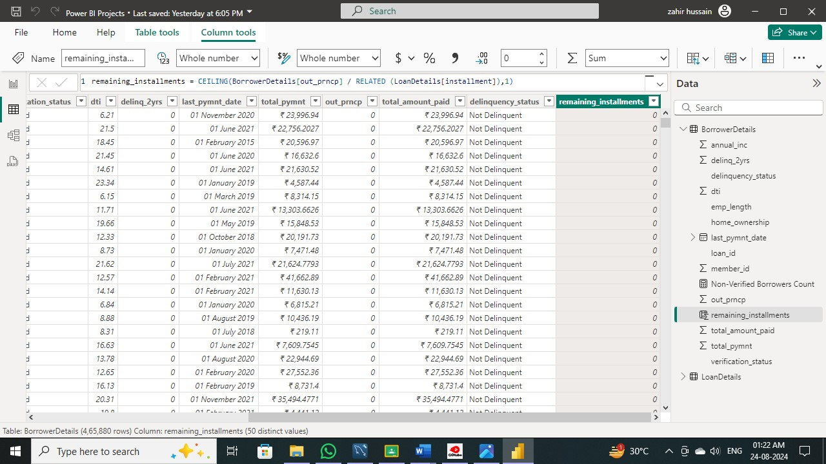

2. Create a measure named 'Non-Verified Borrowers Count' using DAX to count the number of loans that have been 'Not Verified'.

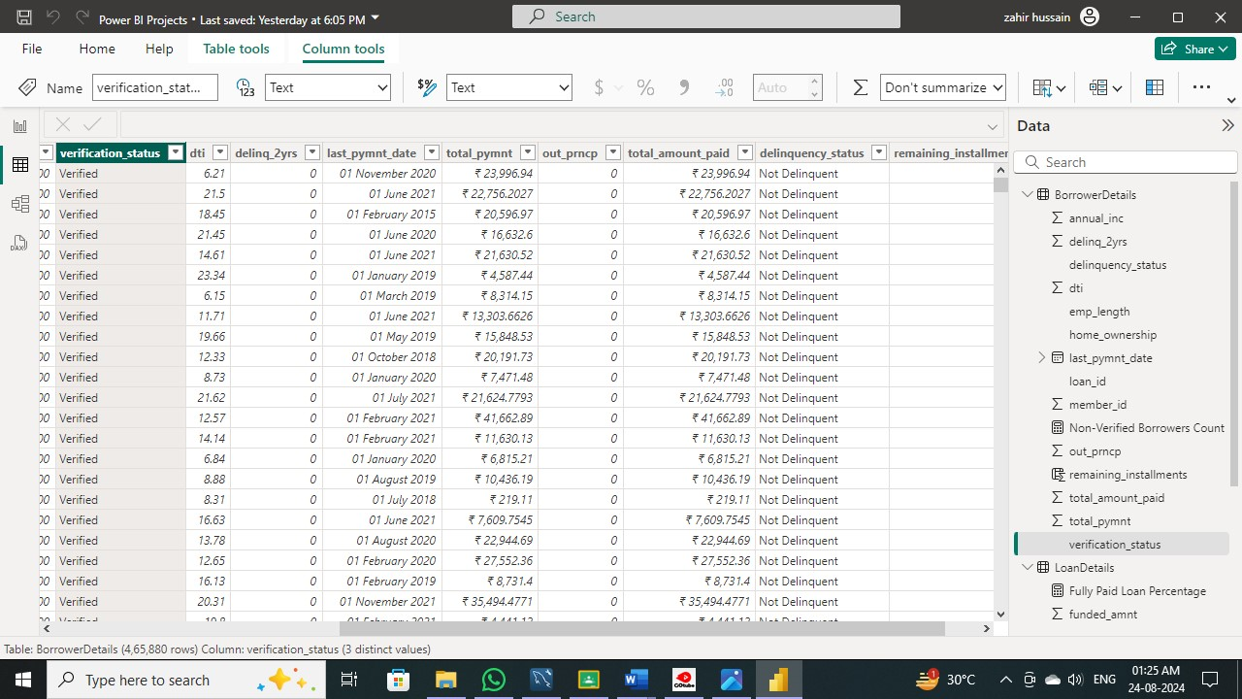

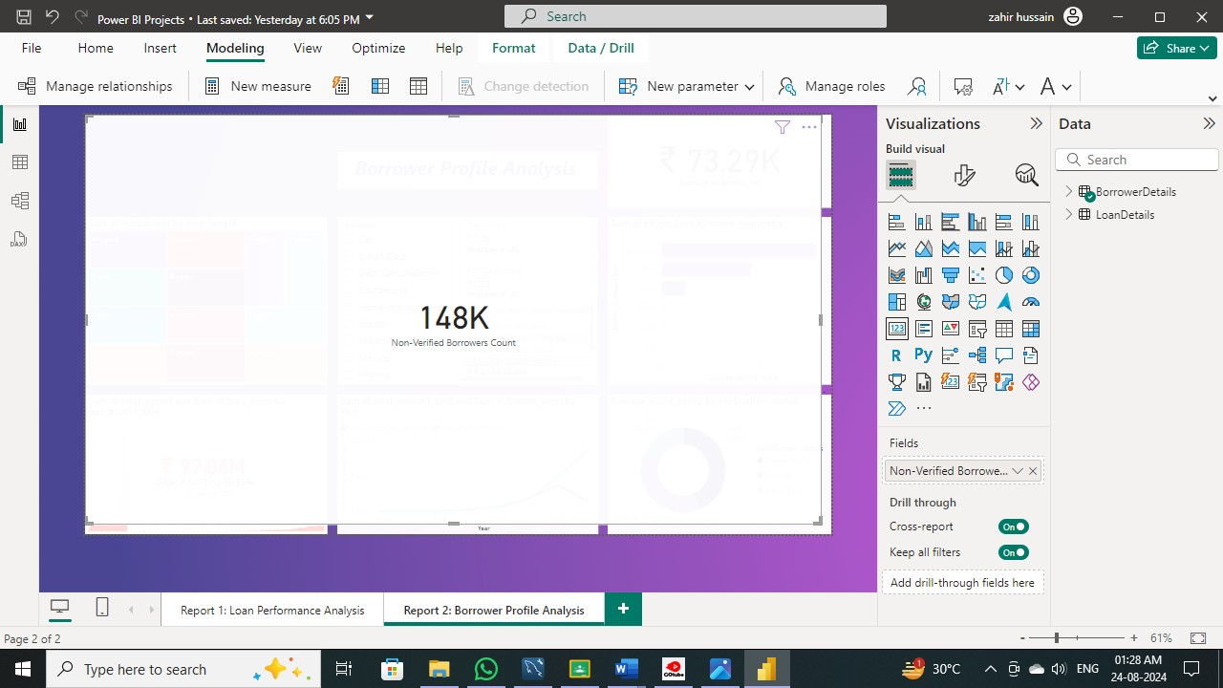

3. Create a measure named 'Fully Paid Loan Percentage' to calculate the percentage of fully paid loans. Divide the number of loans with a "Fully Paid" loan status by the total number of loans and then format this measure as Percentage.

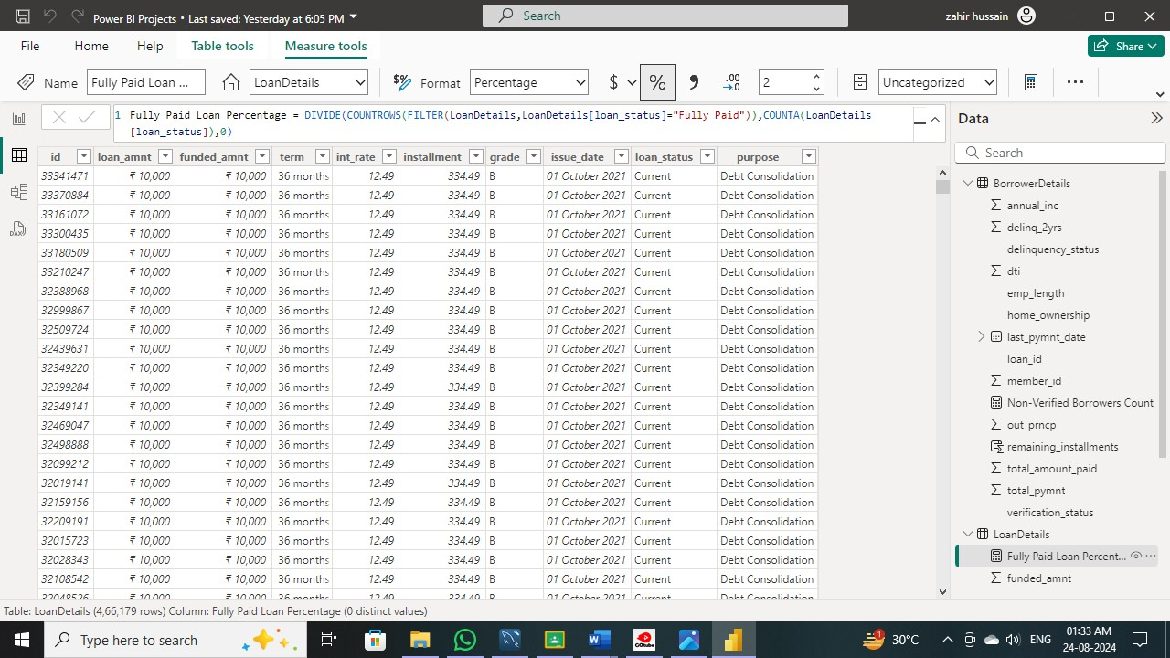

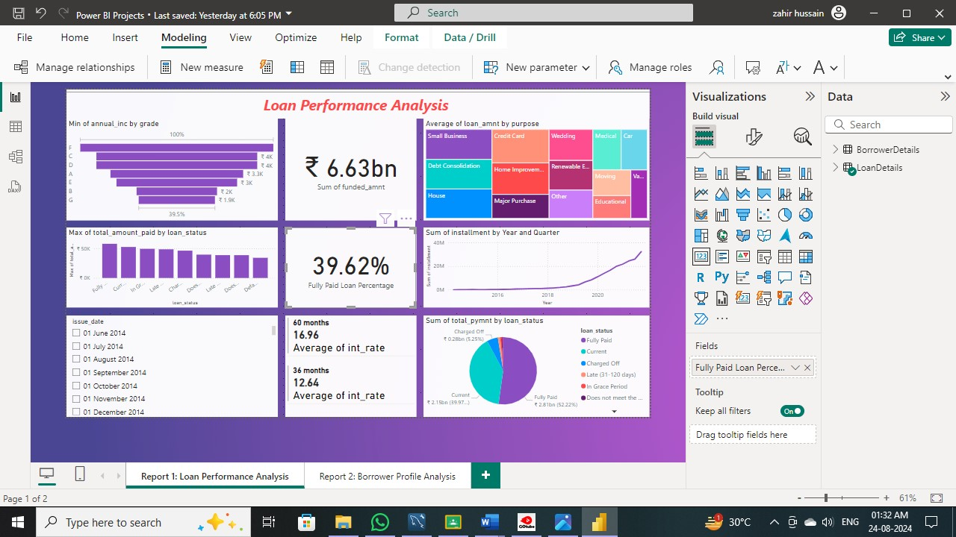



Report 1: Loan Performance Analysis

The Loan Performance Analysis report aims to provide insights into the performance of loans based on various factors such as loan amount, loan status, term, interest rate, and purpose.

1. Total Funded Amount: Create a card visual to display the total funded amount.

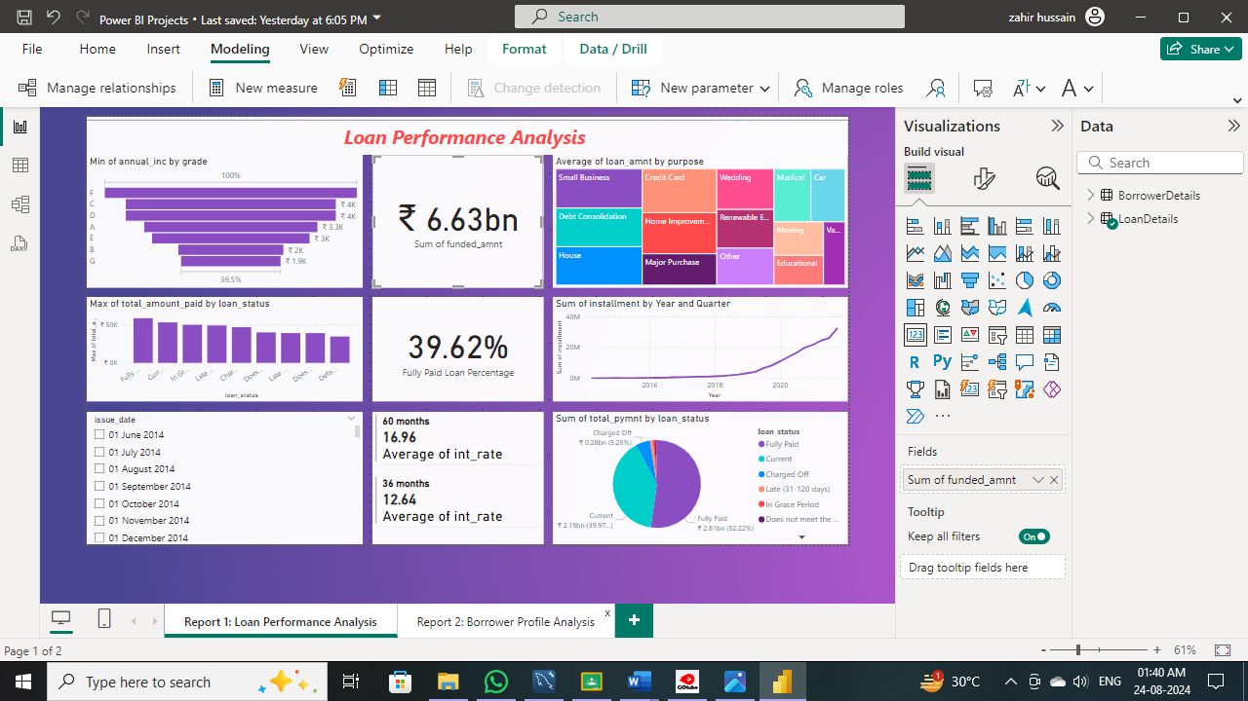

2. Fully Paid Loan Percentage: Create a gauge chart to display the 'Fully Paid Loan Percentage' measure.

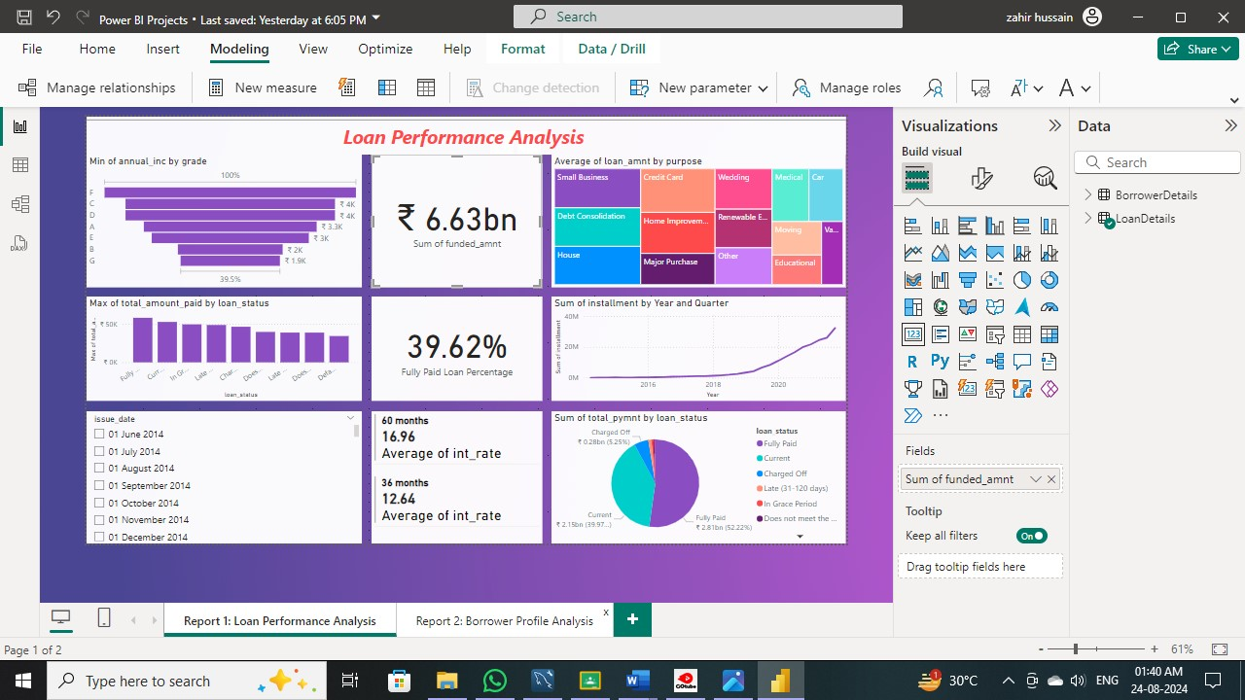

2. Fully Paid Loan Percentage: Create a gauge chart to display the 'Fully Paid Loan Percentage'

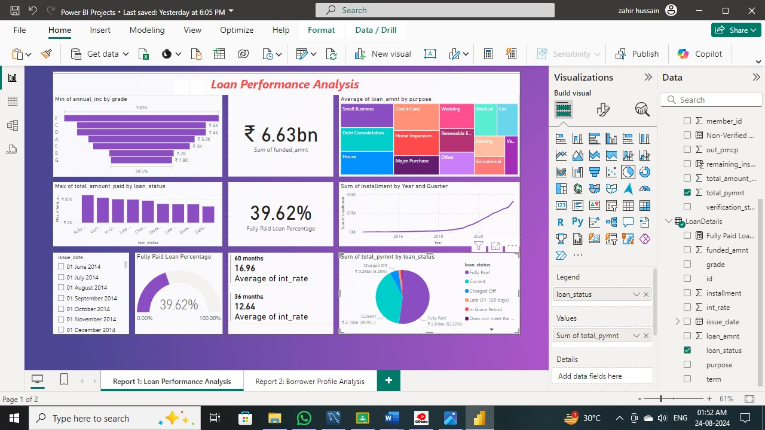

3.Average Interest Rate by Term: Create a multi-row card to show the average interest rate for each term.

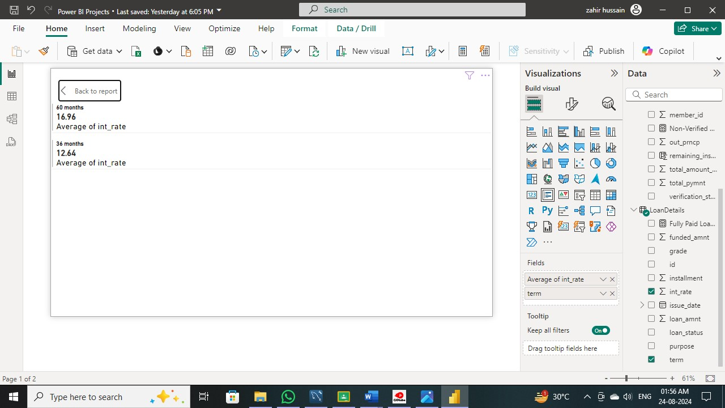

4. Loan Status Distribution: Create a pie chart to visualize the sum of total payments by loan status.

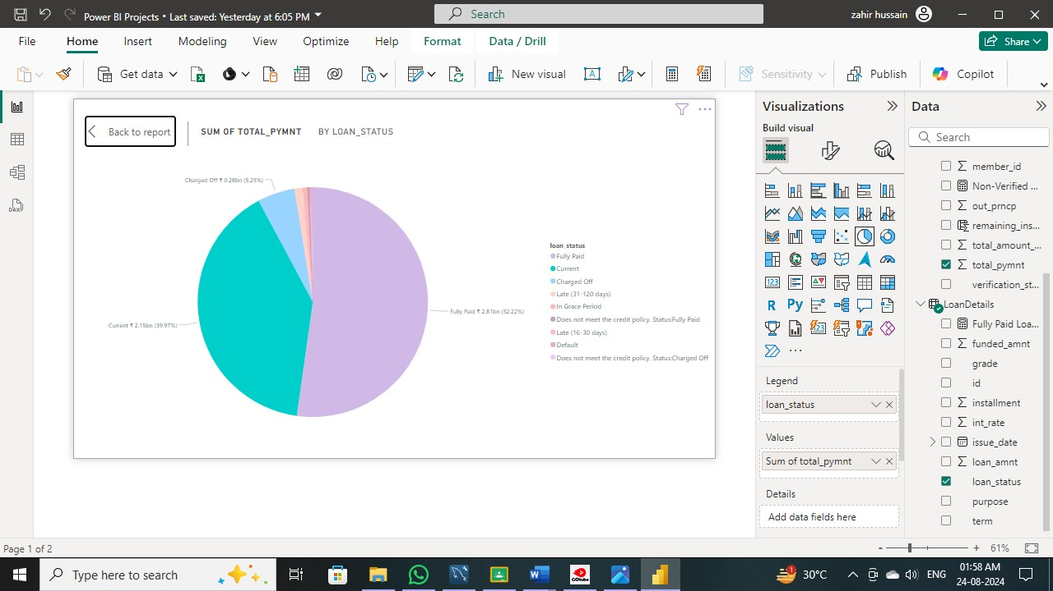

5. Loan Amount by Purpose: Create a treemap to show the average loan amount by purpose.

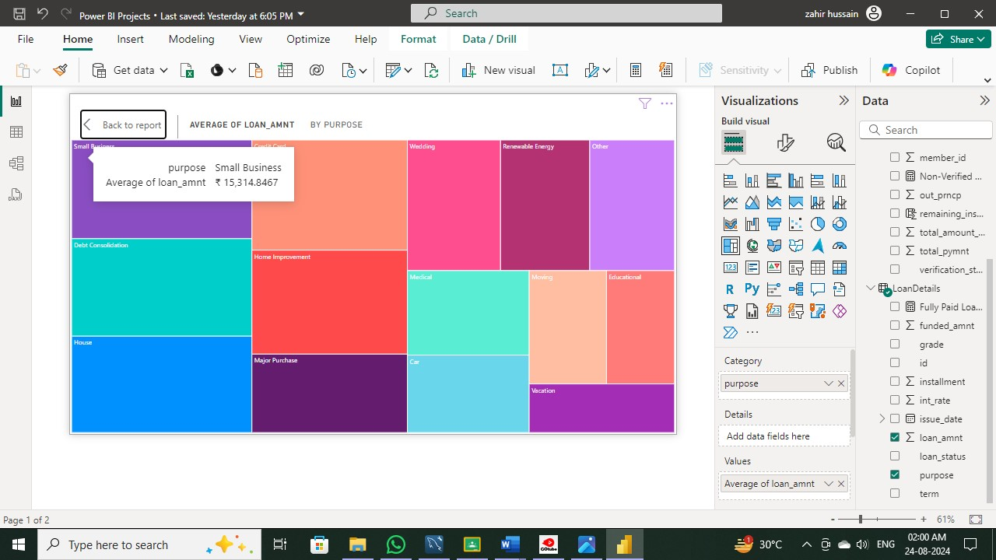

6. Installment Over Time: Create a line chart to visualize the sum of installments by Year and Quarter of the issue date.

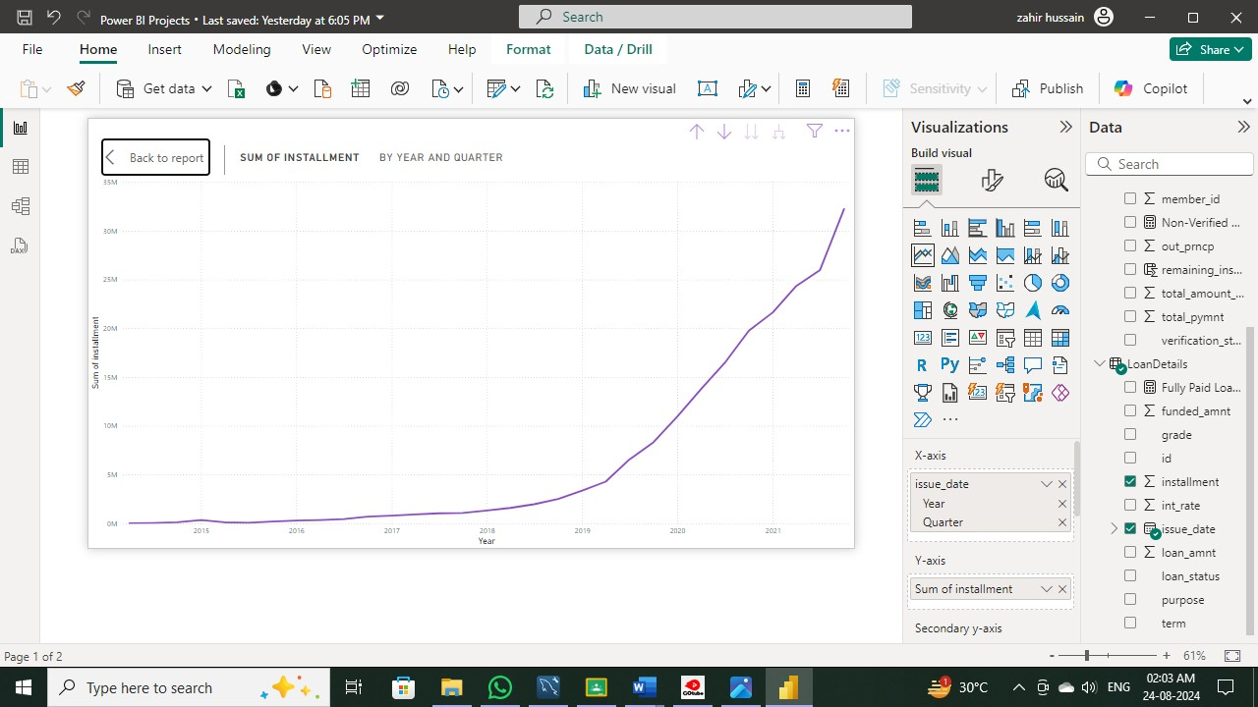

7. Maximum Total Amount Paid by Loan Status: Create a column chart to display the maximum total amount paid by loan status.

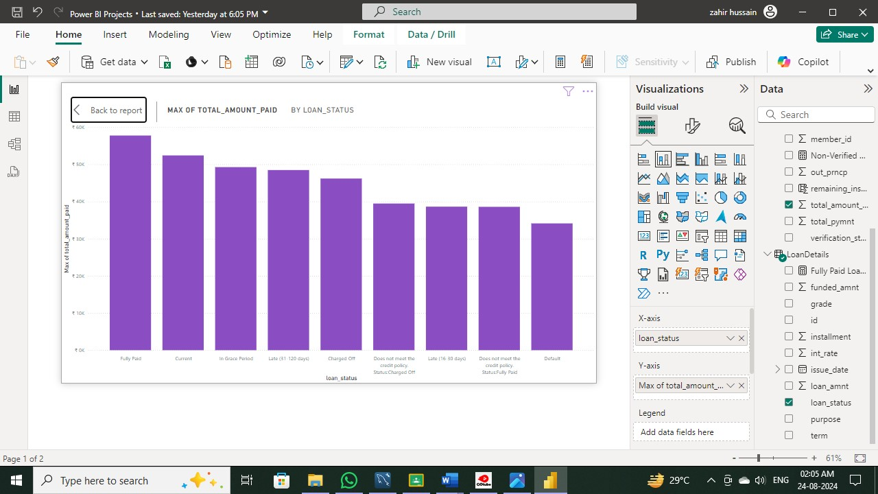

8. Minimum Annual Income by Grade: Create a funnel chart to show the minimum annual income by grade.

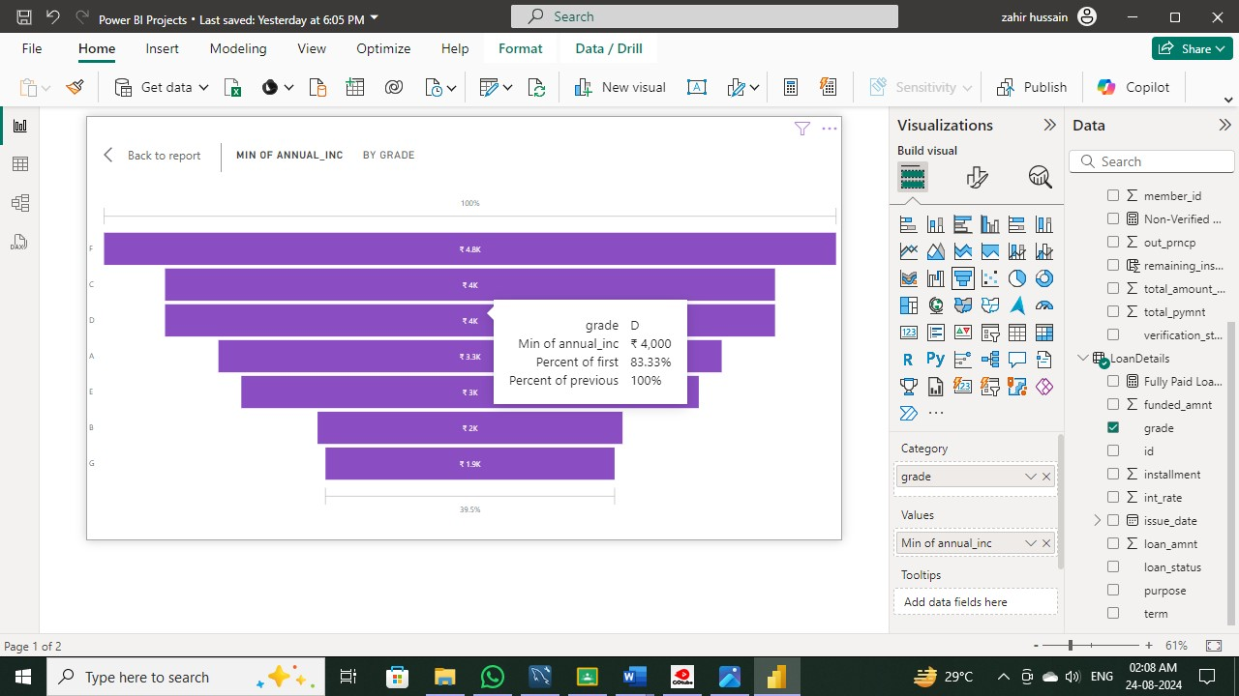

9. Issue Date Slicer: Add a slicer for the Month of the issue date to enable dynamic data exploration.

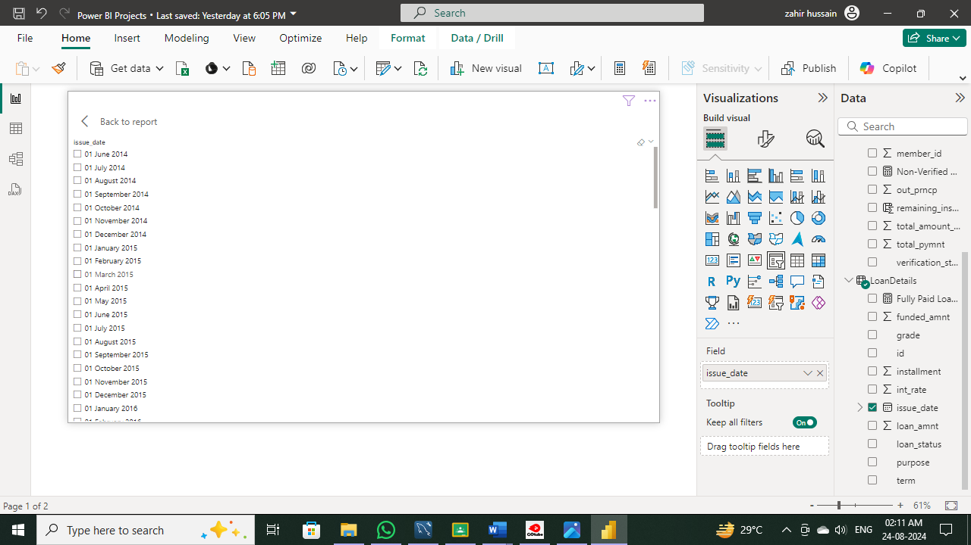

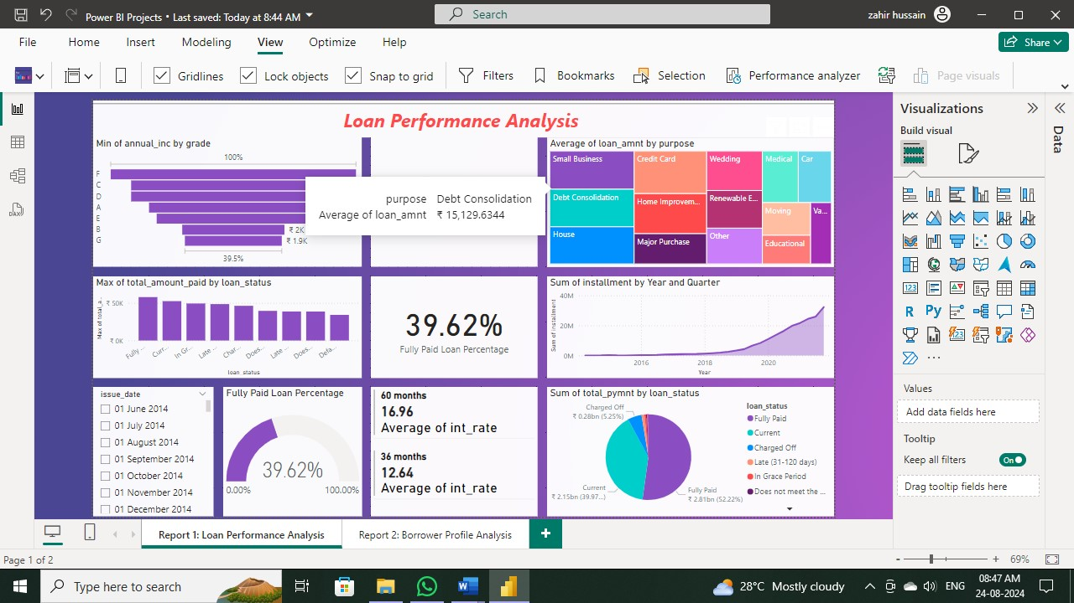

**Report 2: Borrower Profile Analysis**

The Borrower Profile Analysis report aims to provide insights into the characteristics of borrowers such as home ownership, annual income, employment length, verification status, debt-to-income ratio, and delinquency history.

1. **KPI Visual:** Create a KPI visual with the sum of total payment as the value, the year of last payment date as the trend axis, and the sum of loan amount as the target. Round off to 2 decimal points and format as $ currency.

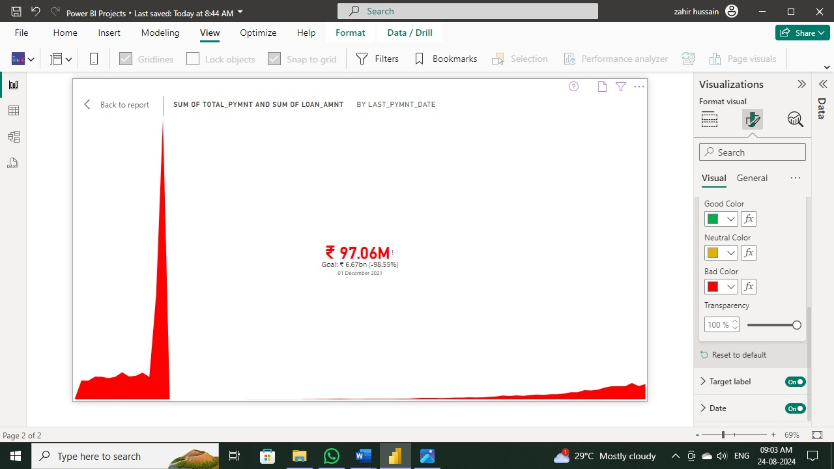

2. Average of Annual Income: Display the average of annual income using a card visual.

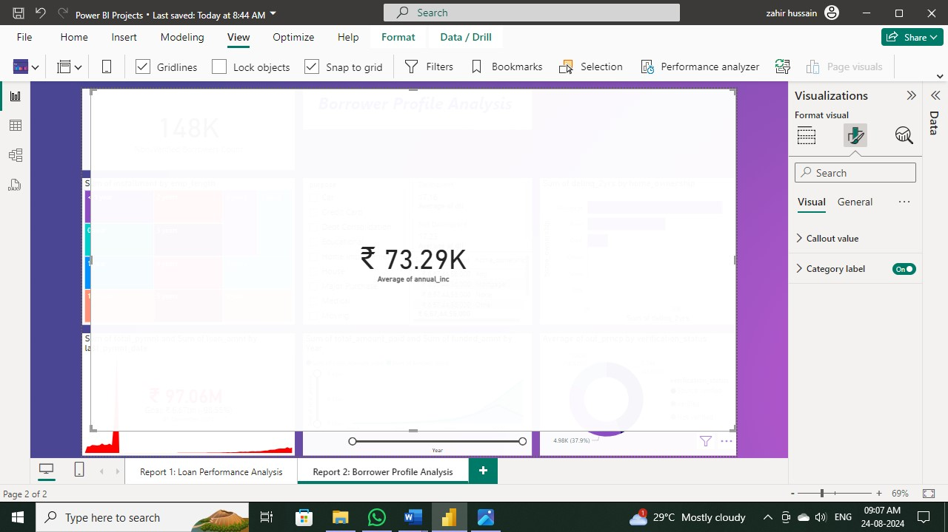

3. Non-Verified Borrowers Count: Display the count of non-verified borrowers using a card visual.

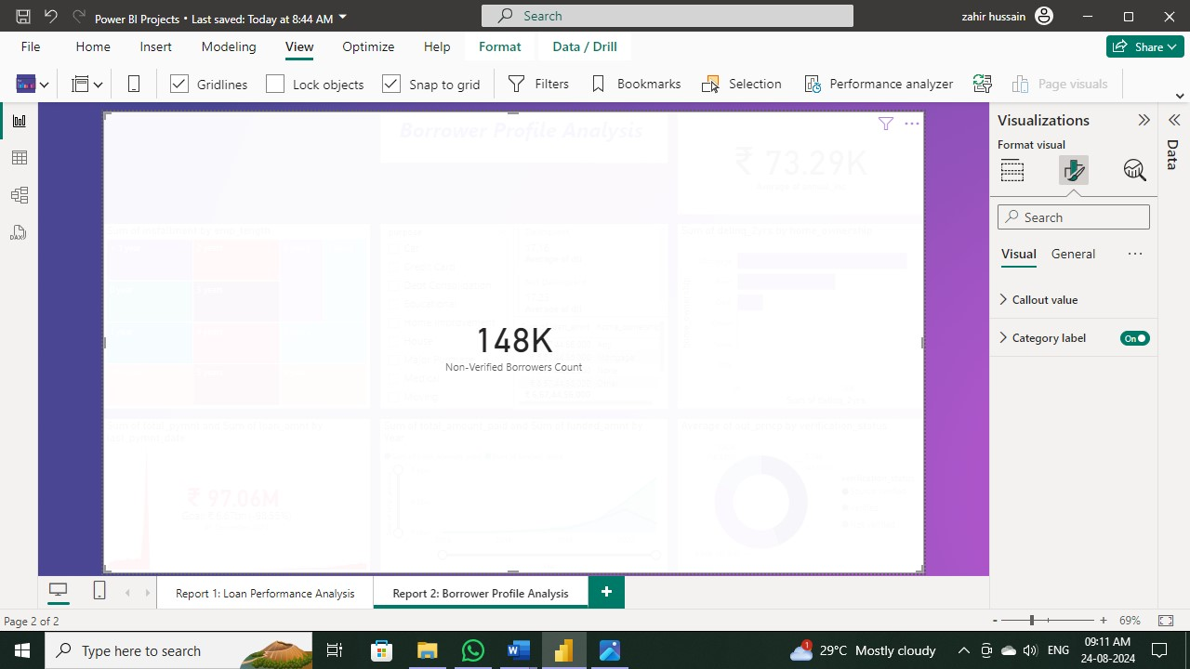

4. Average Debt-to-Income by Delinquency Status: Create a multi-row card to show the average debt-to-income ratio by delinquency status.

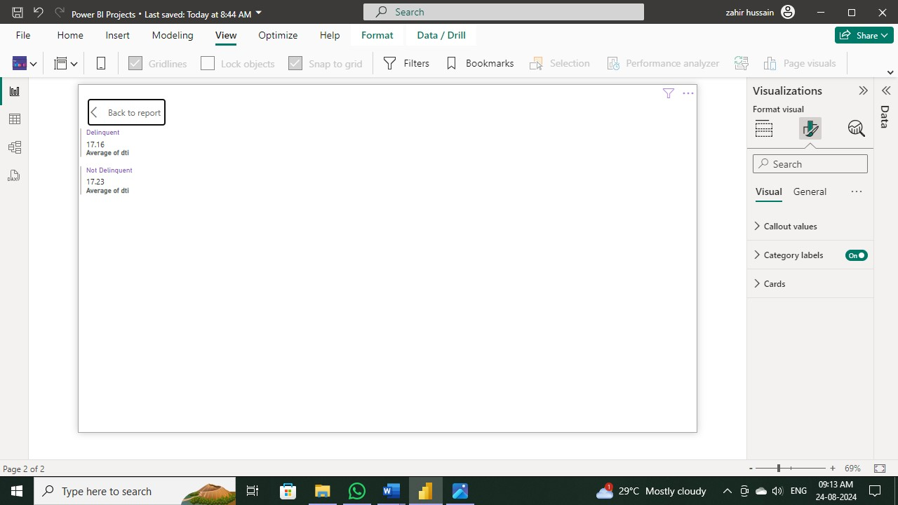

5. Sum of Loan Amount by Home Ownership: Create a table to show the total loan amount by home ownership.

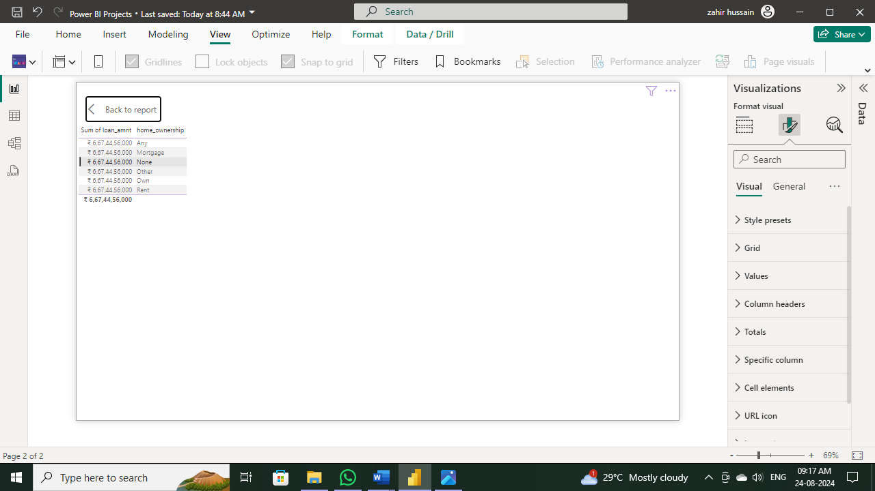

6. Average Remaining Principal by Verification Status: Create a donut chart to display the average remaining outstanding principal by verification status.

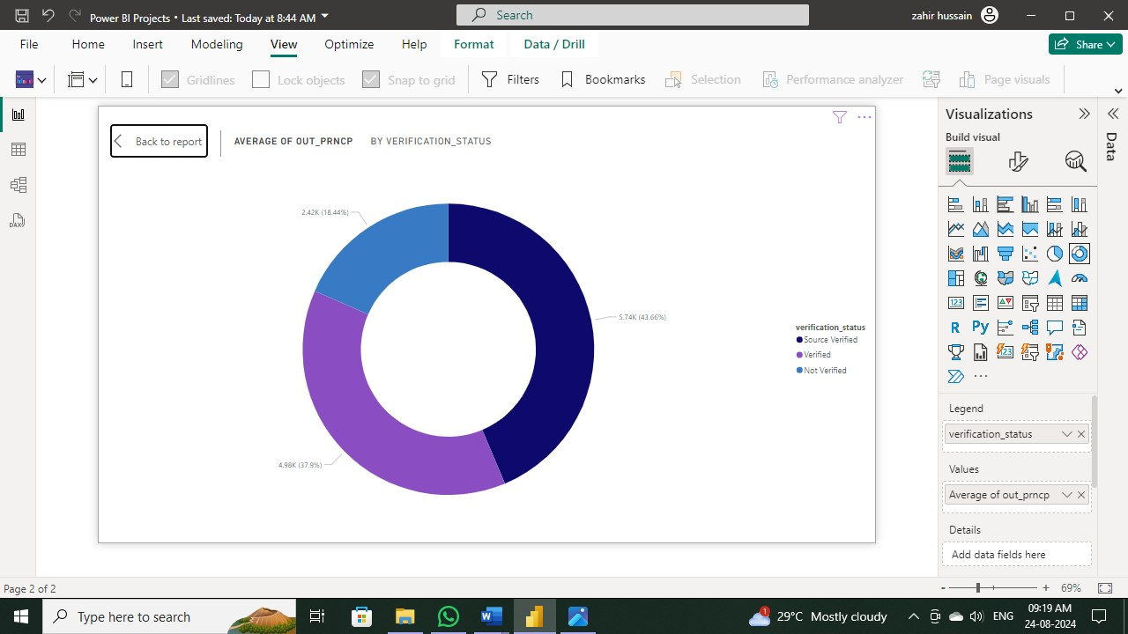

7. Sum of Delinquencies by Home Ownership: Create a bar chart to show the total number of delinquencies in the past 2 years by home ownership and filter the visual to display only Mortgage, Rent, and Own.

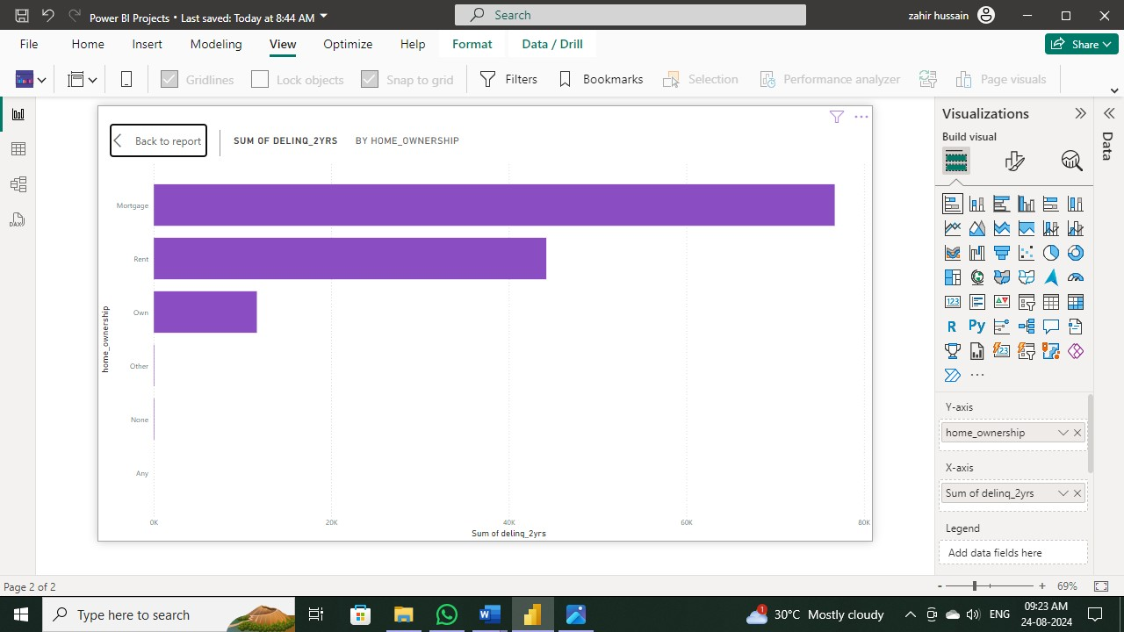

8. Max Remaining Installments by Employment Length: Create a treemap to show the maximum remaining installments by employment length.

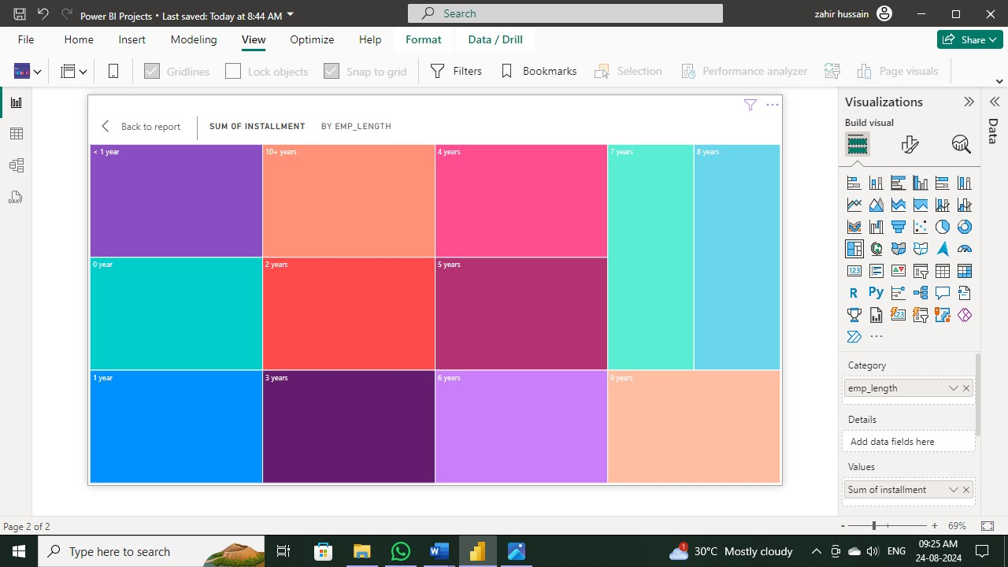

9. Total Amount Paid and Funded Amount Over Time: Create a line chart to display the sum of total amount paid and the sum of funded amount by the year of last payment date.

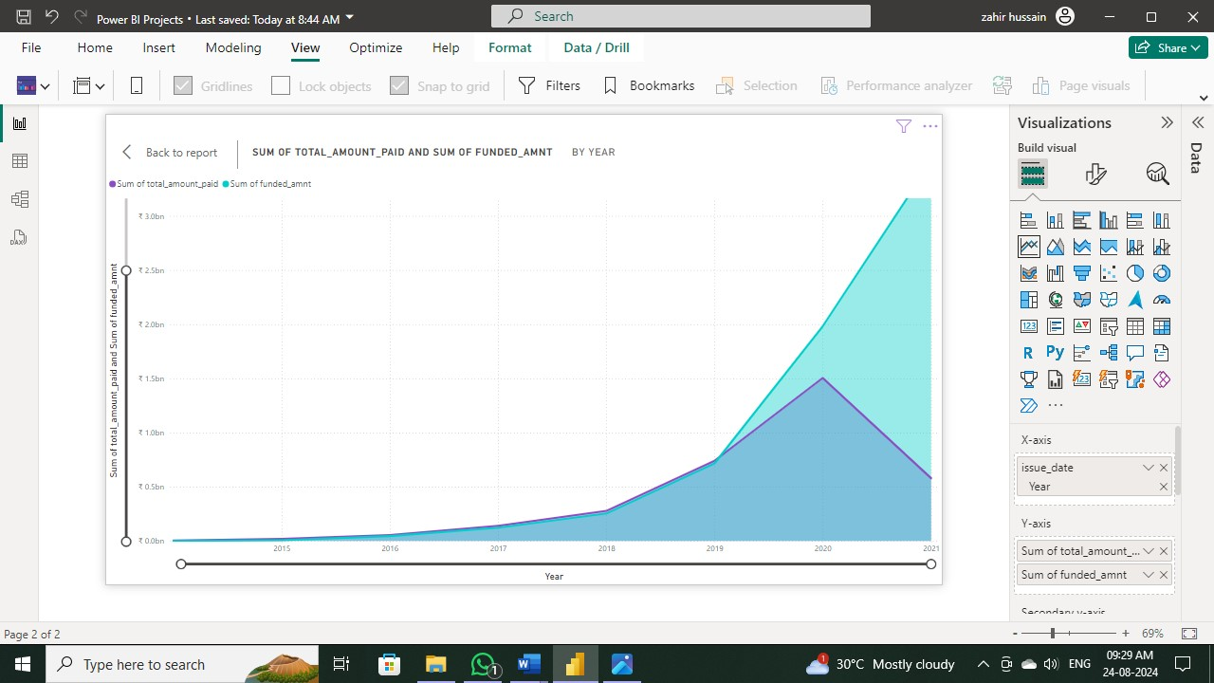

10. Purpose Slicer: Add a slicer for loan purpose to enable dynamic data exploration.

